

**Product Dissection for AJIO**

## Company Overview

**AJIO**, launched in *2016* by **Reliance Retail**, is an innovative online fashion and lifestyle platform that has rapidly gained popularity in India. It offers a curated collection of clothing, accessories, footwear, and electronics from exclusive brands and designers, providing a seamless and personalized shopping experience. AJIO's mission is to redefine online shopping by delivering high-quality products and exceptional customer service.

## Product Dissection and Real-World Problems Solved by AJIO

## Problem 1: Overwhelming Choices and Decision Fatigue

* Real-World Challenge: Shoppers are often overwhelmed by the vast number of products available online, leading to decision fatigue and a suboptimal shopping experience.
* AJIO's Solution: AJIO addresses this challenge by offering curated collections and personalized recommendations based on user preferences and shopping behaviour. This simplifies the shopping process and helps customers discover products that align with their tastes.

Problem 2: Limited Access to Exclusive Brands

* Real-World Challenge: Consumers face difficulties in finding exclusive and high-quality brands online.
* AJIO's Solution: By partnering with exclusive brands and designers, AJIO provides access to a diverse range of high-quality and trendy products, ensuring customers can find unique and desirable items.

Problem 3: Concerns About Product Quality and Authenticity

* Real-World Challenge: Ensuring the quality and authenticity of products is a major concern for online shoppers.
* AJIO's Solution: AJIO guarantees the authenticity and quality of its products by sourcing directly from brands and designers. The platform's stringent quality control measures and hassle-free return policy further build customer trust and confidence.

Problem 4: Personalized Shopping Experience

* Real-World Challenge: Traditional online shopping platforms often fail to provide a personalized shopping experience.
* AJIO's Solution: AJIO utilizes advanced algorithms and data analytics to offer personalized product recommendations, creating a tailored shopping experience for each user.

Case Study: Real-World Problems and AJIO's Innovative Solutions

Problem 1: Overwhelming Choices and Decision Fatigue

* Real-World Challenge: Shoppers often experience decision fatigue due to the vast number of products available online.
* AJIO's Solution: AJIO addresses this challenge by offering curated collections and personalized recommendations. By analysing user preferences and shopping behaviour, the platform suggests products that align with individual tastes, making the shopping experience more enjoyable and less overwhelming.

Problem 2: Limited Availability of Exclusive and Niche Brands

* Real-World Challenge: Finding exclusive and niche brands online can be challenging for consumers.
* AJIO's Solution: AJIO collaborates with exclusive brands and designers to offer unique and high-quality products. This approach not only enhances the platform's appeal but also ensures that customers have access to a diverse range of trendy and exclusive items.

Problem 3: Concerns About Product Quality and Authenticity

* Real-World Challenge: Ensuring product quality and authenticity is a major concern for online shoppers.
* AJIO's Solution: AJIO guarantees the authenticity and quality of its products by sourcing directly from brands and designers. The platform's stringent quality control measures and hassle-free return policy further build customer trust and confidence.

Top Features of AJIO

* User Profiles: Users can create personalized profiles, track orders, manage wishlists, and view purchase history.
* Product Listings: Detailed product listings with high-quality images, descriptions, prices, and reviews.
* Curated Collections: Handpicked collections catering to different styles, occasions, and preferences.
* Exclusive Brands: Access to exclusive and high-quality brands and designers.
* Recommendations: Personalized product recommendations based on user preferences and shopping behaviour.
* Wishlist: Users can add desired products to their wishlist for future purchases.
* Shopping Cart: A convenient shopping cart for easy checkout and order management.
* Order Tracking: Real-time order tracking and updates.
* Hassle-Free Returns: Easy and hassle-free return policy to ensure customer satisfaction.
* Customer Support: 24/7 customer support to assist with any queries or issues.

Schema Description

* User Entity:
* **UserID (Primary Key):** A unique identifier for each user.
* **Username**: The chosen username for the user's account.
* **Email**: The user's email address for account-related communication.
* **Full_Name**: The user's full name.
* **Password**: The user's password for account access.
* **Registration_Date**: The date when the user registered on AJIO.
* Product Entity:
* **ProductID (Primary Key):** A unique identifier for each product.
* **Product_Name**: The name of the product.
* **Description**: A detailed description of the product.
* **Price**: The price of the product.
* **Brand**: The brand of the product.
* **Category**: The category to which the product belongs.
* **Stock**: The available stock quantity.
* **Image_URL**: The URL of the product image.
* Order Entity:
* **OrderID (Primary Key):** A unique identifier for each order.
* **UserID (Foreign Key referencing User Entity):** The user who placed the order.
* **Order_Date:** The date when the order was placed.
* **Total_Amount**: The total amount of the order.
* **Status:** The current status of the order (e.g., Pending, Shipped, Delivered).
* Review Entity:
* **ReviewID (Primary Key):** A unique identifier for each review.
* **ProductID (Foreign Key referencing Product Entity**): The product being reviewed.
* **UserID (Foreign Key referencing User Entity):** The user who wrote the review.
* **Rating:** The rating given by the user (e.g., 1 to 5 stars).
* **Comment:** The text of the review.
* **Review_Date**: The date when the review was posted.
* Wishlist Entity:
* **WishlistID (Primary Key):** A unique identifier for each wishlist item.
* **UserID (Foreign Key referencing User Entity):** The user who added the product to their wishlist.
* **ProductID (Foreign Key referencing Product Entity):** The product added to the wishlist.
* **Added_Date**: The date when the product was added to the wishlist.
* Cart Entity:
* **CartID (Primary Key):** A unique identifier for each cart item.
* **UserID (Foreign Key referencing User Entity):** The user who added the product to their cart.
* **ProductID (Foreign Key referencing Product Entity):** The product added to the cart.
* **Quantity:** The quantity of the product added to the cart**.**
* **Added_Date:** The date when the product was added to the cart.

Relationships:

* Users place Orders – Each user can place multiple orders.
* Users write Reviews for Products – Users can write reviews for multiple products, and each product can have multiple reviews.
* Users add Products to Wishlist – Users can add multiple products to their wishlist, and each product can be added to multiple wishlists.
* Users add Products to Cart – Users can add multiple products to their cart, and each product can be added to multiple carts.

ER Diagram

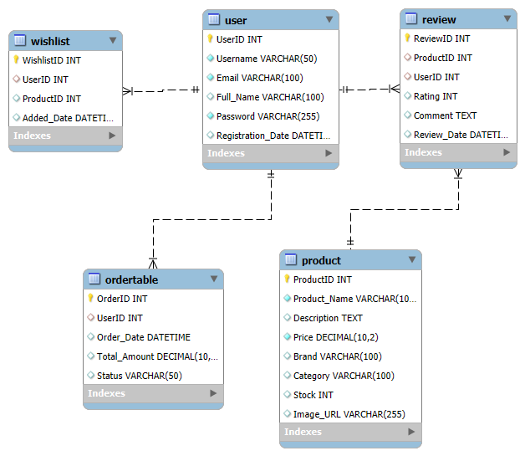

Conclusion

This expanded project on AJIO covers various aspects of the platform, including its company overview, the problems it addresses, its top features, and a detailed schema description. The enhanced ER diagram provides a clear and attractive visualization of the relationships and attributes of the entities within AJIO's schema.